**SIR APOLLO**

**END OF TERM III EXAMINATION 2023**

**P.5 MATHEMATICS**

***Time Allowed: 2hours 30 Minutes***

**Pupil’s Name: …………………….……………………………………**

**Class: ………………………………….……………………………………**

**School Name: ……………………………………………………………**

|  |  |  |
| --- | --- | --- |
| **FOR EXAMINERS’**  USE ONLY | | |
| **Qn. No.** | **MARKS** | **EXR’S**  **No.** |
| **1 - 10** |  |  |
| **11 – 20** |  |  |
| **21 – 30** |  |  |
| **31 – 32** |  |  |
| **TOTAL** |  |  |

**Read the following instructions carefully:**

1. This paper has two sections: **A** and **B**
2. Section **A**has 20 short questions (40 marks)
3. Section **B** has 12 questions (60 marks)
4. Answer allquestions. All the working for both sections Aand Bmust be shown in the spaces provided.
5. Allworking must be done using a blueor blackball point pen or ink. Any work done in pencil will NOT be marked except drawings and diagram.
6. Unnecessary changesin your work and handwriting that cannot be easily read may lead to loss of marks.
7. Do not fill anything in the table indicated

**“For examiners’ use only”**and the boxes inside the question paper.

**Turn Over**

**SECTION : A (40 Marks).**

1. Divide 6 ÷ 2 =

2. Solve y + 6 = 13.

3. Find the square of 9.

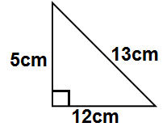4. Calculate the area of the figure below.

5. Write 2011 in words.

6. Shade A U B in the Venn diagram below.

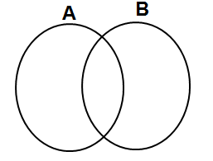

7. Change 2.5kg to grammes.

8. Write down the next two numbers in the sequence below;

1, 4, 9, 16, ___, ____

9. 5 pens cost sh. 6,000/=, find the cost of 7 similar pens at the same rate.

10. Subtract 2 0 4 five

- 1 1 3 five

11. Arrange the following integers in ascending order. – 6 , 0, -4, -3 , 4.

12. Find the volume of the cube below.

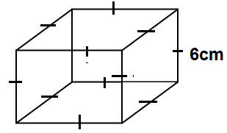

13. Reduce to the lowest term 16.

40

14. Find the value of the angle marked y in the figure below.

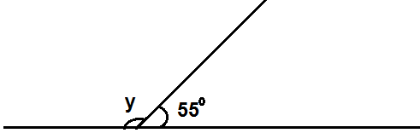

15. Round off 17.673 to the nearest tenths.

16. James bought a cow at sh. 860,000 and sold it at shs. 900,000. Work out his profit.

17. Work out Wks Days

5 4

+ 1 5

18. Expand 27.392 using indices.

19. Mayanja is 16 years old. Kamya is 9 years older than Mayanja.

a) How old is Kamya. (1mk)

b) Find their total age. (1mk)

20. Using a sharp pencil, a ruler and a pair of compasses only, construct an angle of 600 in the space provided below.

**SECTION : B (60 Marks)**

21. Given that a=3, b=4 and c=5. Find the value of ;

i) abc (1mk)

ii) (a + c) – b (2mks)

iii) bc + 4 (2mks)

a

22. Study the figure below and answer the questions that follow.

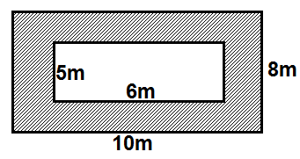

a) Find the area of the outer rectangle.

(2mks)

b) Find the area of the inner rectangle.

(2mks)

c) Calculate the area of the shaded part. (1mk)

\

23. Namatovu scored the following marks in a series of Maths tests.

40, 70, 20, 60 and 60.

a) What was the range of her scores?

(1mk)

b) Find the median mark. (1mk)

c) Calculate her average score. (2mk)

24. Study the Venn diagram below and answer the questions that follow.

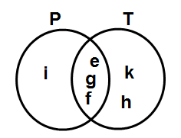

a) Find ( i) Set (P ∩ T) (1mk)

ii) Set (T - P) (1mk)

iii) n(P U T) (2mks)

b) How many subsets can be formed from Set T only? (1mk)

25. Calculate the size of the unknown angles in each of the figures below.

(2mks)

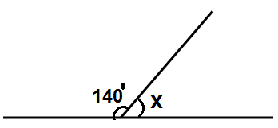a)

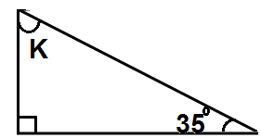

b) (2mks)

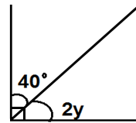

c) (2mks)

26. Richard went to the market and bought the items as shown below.

|  |  |  |  |
| --- | --- | --- | --- |
| **Item** | **Quality** | **Unit cost** | **Total cost** |
| Rice | 2kg | 2000/= per kg | sh_____ |
| Soap | 3 bars | _____ @ bar | sh.3600 |
| Salt | _____kg | 1000 per kg | sh. 2000 |
| milk | 2litres | ____ per litre | sh. 2400 |
| **Total** | | |  |

Complete the shopping bill above. (Show the working) (5mks)

27a) Change 32five to base ten. (2mks)

b) Express 14ten to base five. (2mks)

c) Add : 1 0 1 1 two (2mks)

+ 1 1two

28. The figure below is a rectangular prism. Study it carefully and use it to answer the questions that follow.

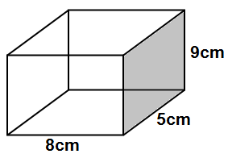

a) How many vertices does it have?

(1mk)

b) Find its volume? (1mk)

c) Calculate the area of the shaded

part. (2mks)

29. There are 60 teachers in Dumo P/S School,, of them teach upper school and the rest teach the lower school.

a) Find the fraction of teachers that teach the lower school. (2mks)

b) If the Head teacher gave 2 pens to each teacher in the upper school, what was the total number of pens given out? (3mks)

30a) **Use >, < or = to complete the following correctly.**

i) - 4 ___________ 0 (1mk)

ii) 3kg ___________ 3500g (1mk)

b) Work out:

i) - 4 + - 2 = (1mk)

ii) +3 + - 5 = (1mk)

31. Find the smaller angle between South West and North. (2mks)

b) Namuli was facing East. She turned anti-clock wise to face North West. Through what angle did she turn?

(2mks)

c) Construct an equilateral triangle ABC of sides 5cm each. (2mks)

32a) Write down multiples of 7 less than 30. (1mk)

b) Find the GCF of 8 and 12. (2mk)

c) Work out the square root of 36. (2mks)

